Speaking Invoice

1 | Leadership Success LIVE seminar | $550.00
 | total | $550.00

Employer Identification number: 20-1453385

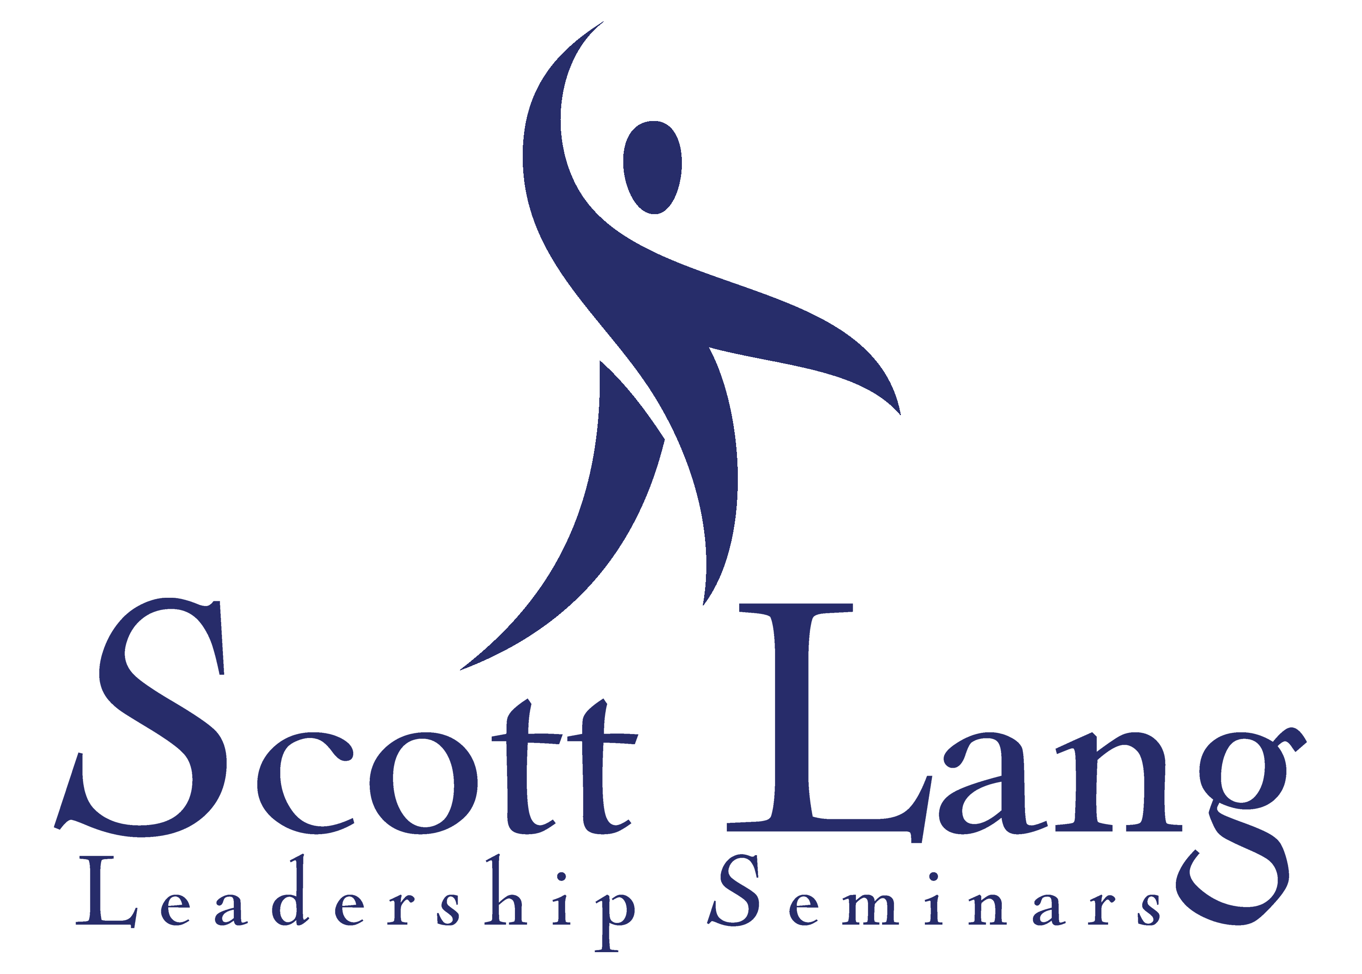
Checks should be made c/o Scott Lang and payable to:
505 South Camellia Drive
Chandler, Arizona 85225
(480) 577-5264
505 South Camellia Drive
Chandler, Arizona 85225
(480) 577-5264

Scott Lang L.L.C.
505 South Camellia Drive
Chandler, Arizona 85225
(480) 577-5264

